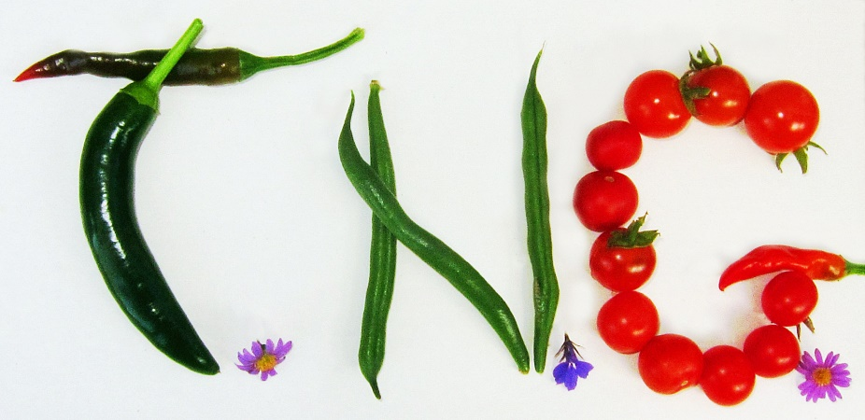

IDEAS AND SUGGESTIONS
Do you have any ideas to improve the garden or benefit the community? We are interested in understanding what our members would like to change or improve in the garden. Our planning committee would like to work with members on their ideas and suggestions.
Please fill your idea in below. We will then contact you to discuss how we might develop this idea.
PROJECT IDEA – please describe your idea.

Name: Email or phone:

